**Java 11 Features:**

* **low-latency garbage collectors:**

In Java, low-latency garbage collectors are designed to minimize pause times during memory management, making them ideal for applications that require real-time responsiveness (e.g., trading systems, gaming, or high-performance servers).

* **No-Op (Epsilon) Garbage Collector:**

**The Garbage collector doesn’t reclaim the memory and when the heap becomes full ,the application will termiate and it throw out of memory exception**

**It’s primarily used for performance testing in non-prod env.**

* **Java Flight Recorder:**

In Java 11, Flight Recorder (also known as JFR – Java Flight Recorder) is a powerful profiling and diagnostics tool built directly into the JVM. It allows developers and operations teams to collect detailed runtime information about a Java application with minimal performance overhead.

* **Retired Nashorn JavaScript Engine**
* **Introduced new Methods for String Manipulation (Strip(),isBlank())**
* **Introduced var Key word in Lambda**
* **SingleFile Source code program🡪 for running a single java program without compilation**
* **HttpClient is optimized for sending request and response.**
* **File.readString is introduced for file prsing**

**Java 17:**

**1. Sealed Classes**

* Restrict which classes can extend or implement a class/interface.
* Improves control over inheritance.

**2.Pattern Matching for instanceof (Standard)**

* Simplifies type checks and casting.

**3.** **Switch Expressions (Standardized)**

* Allows switch to return values.
* Uses -> and yield**.**

**4.Foreign Function & Memory API (Incubator)**

* Interact with native code and memory safely and efficiently.
* Replaces JNI for many use cases.

**5.Deprecations and Removals**

* Removal of older APIs and features like:

RMI Activation system

**6. Performance Improvements**

* Enhanced garbage collection (G1, ZGC).
* Improved startup and throughput.

**7.Hiding JDK Internal Classes**

* Internal JDK classes are hidden by default
* Improve security, stability, and maintainability

**Switch Case:**

**->Arrow syntax replaces : and breakyieldUsed to return a value from a blockMultiple case labelscase "MON", "TUE" etc.Switch as expressionAssigns result directly to a variable**

**Strong Encapsulation of internal JDK classes**

**Java Platform Independent:**

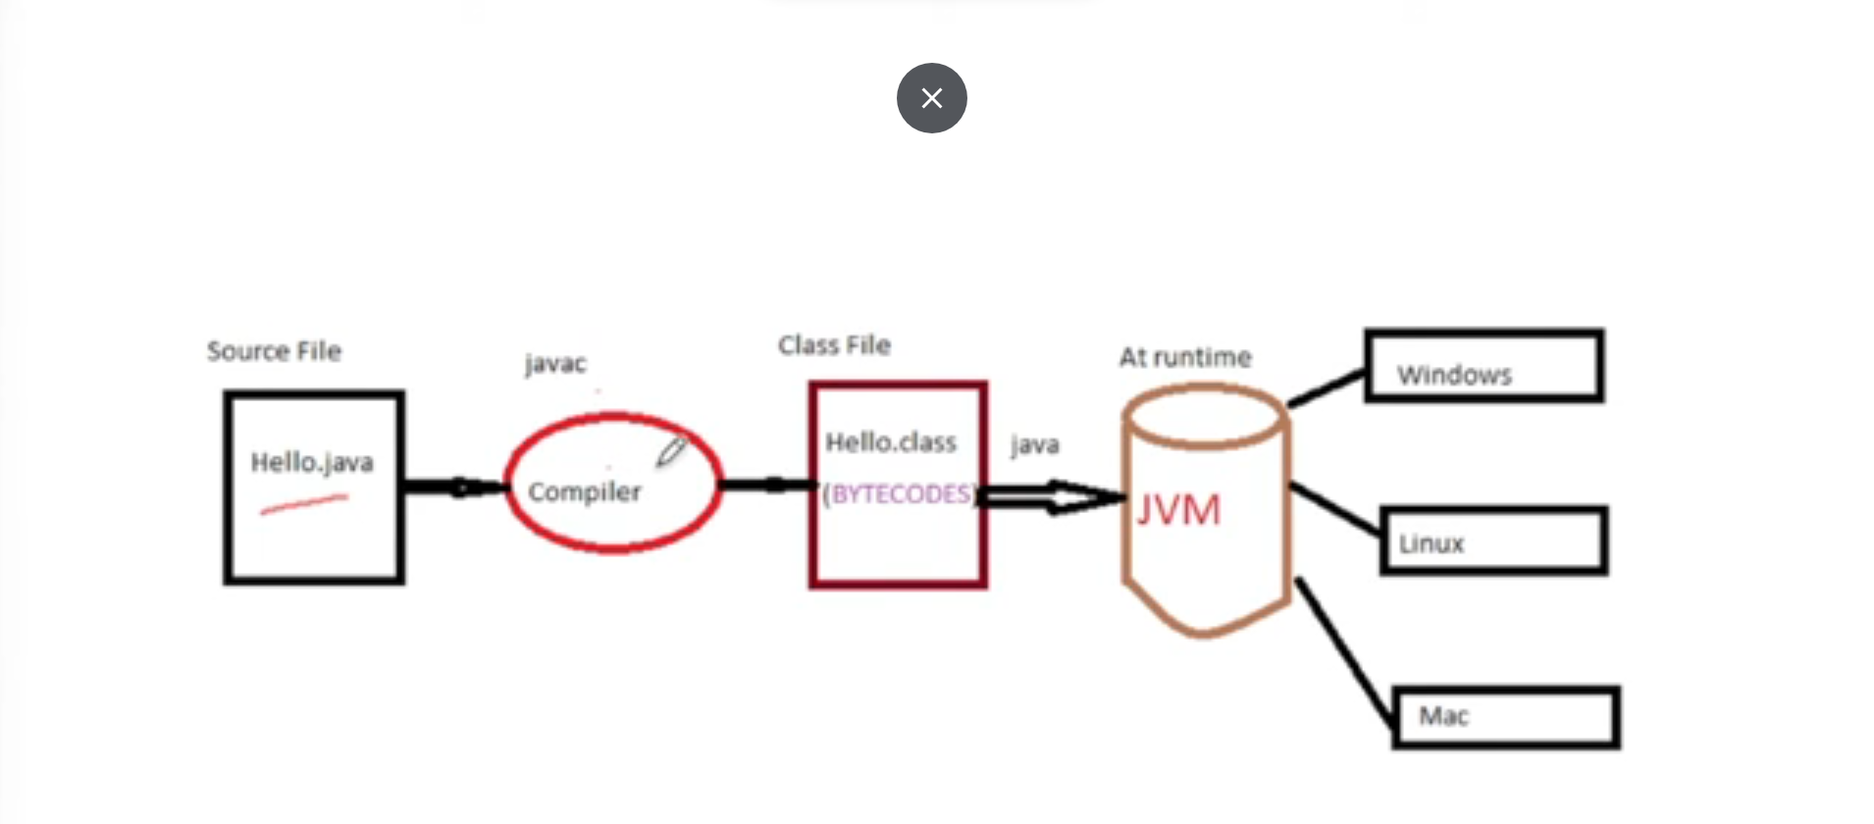

**Coupling:**

Coupling: How much work is involved in changing something?

Loose coupling is preferred because it makes the system more maintainable and adaptable to changes, as components can be modified independently.

**Spring Container:**

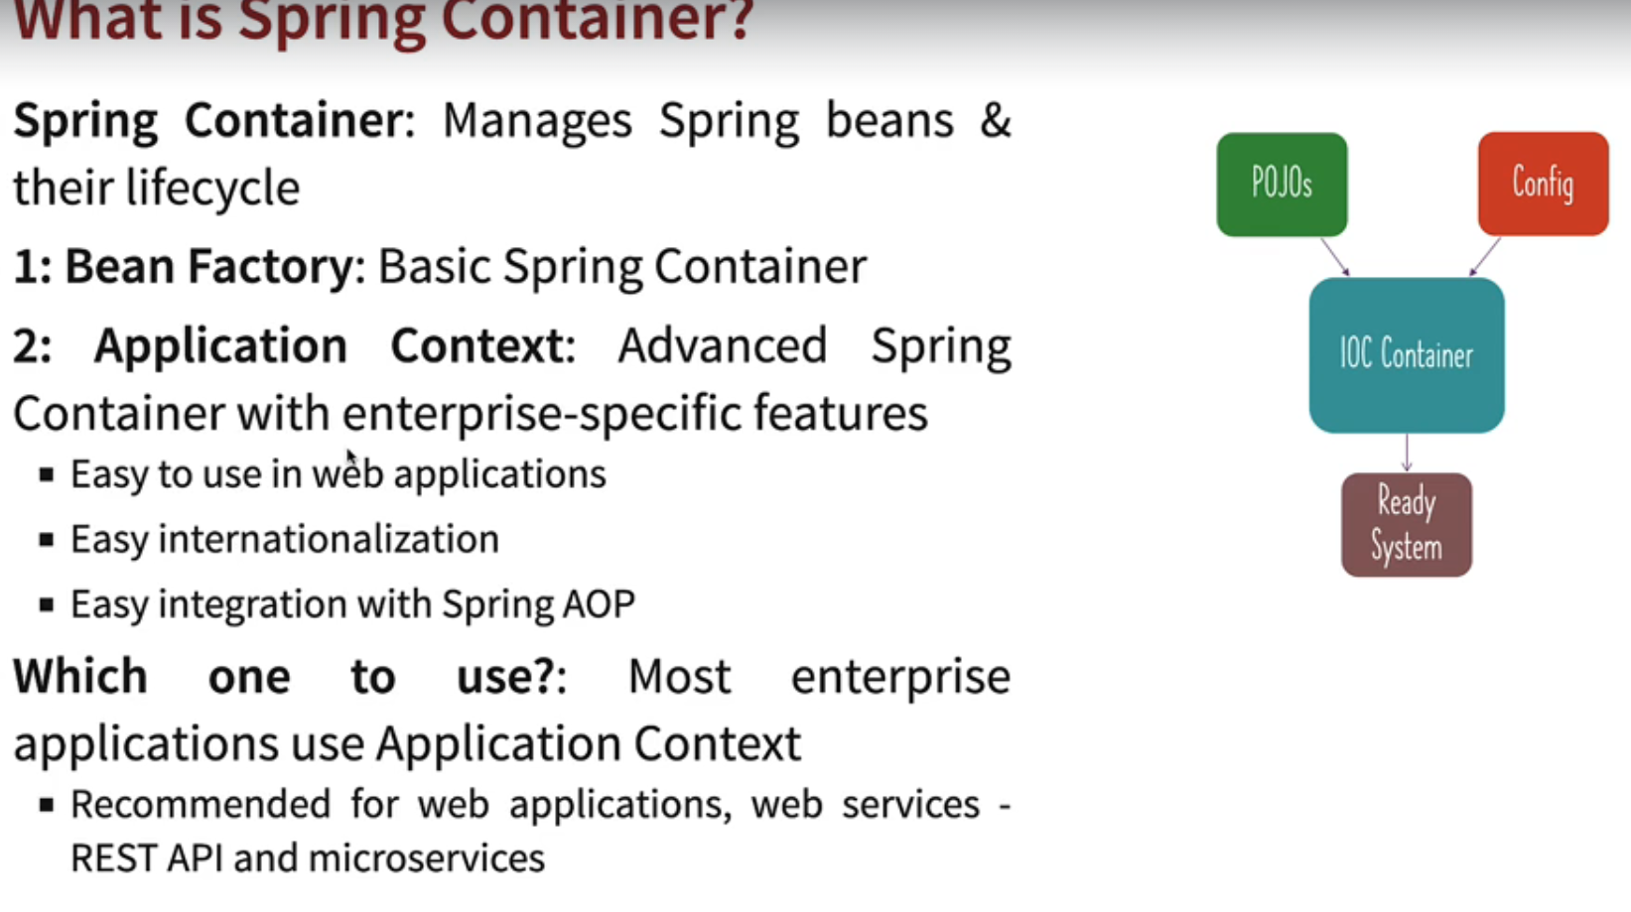

Bean:

Anything (java class) that’s managed by spring container is called spring bean.

Spring bean is managed by spring bean factory or application context.

|  |
| --- |
| **POJO (Plain Old Java Object)**   * **Definition:** A simple Java object with no constraints or dependencies on any specific framework. |
| **Java Bean**   * **Definition:** A POJO that adheres to certain conventions:   + Must have a no-argument constructor.   + Must have getters and setters for properties (fields).   + May optionally implement Serializable or Cloneable interfaces.   **Spring Bean**   * **Definition:** A Java object managed by the Spring Framework's IoC (Inversion of Control) container. |

**Dependency Injection:**

Identify beans,their dependency and wire them together (i.e it provides inversion of control).

Spring Hierarchy:

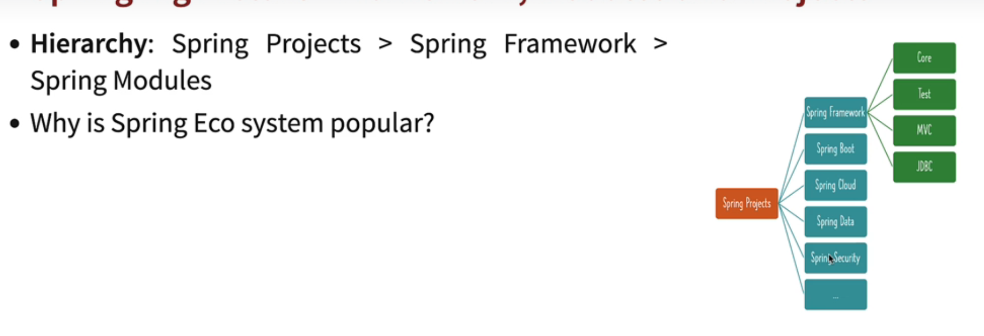

**Types of Injection:**

Constructor

Setter

Field

**@Bean:**

Bean is used to create objects for 3rd party class which are not accessible to make @component on them.

**Bean Initialization:**

Default initialization is **Eager Initialization** (i.e Beans will be created after the spring context is created)

**Lazy Initialization:** This indicates the lazy initialization of the spring Bean.

**Bean Scope:**

The prototype scope is a bean definition that instructs the Spring container to create a new instance of the bean every time it's requested. This is in contrast to the default singleton scope, where only one instance of the bean is created and shared throughout the application.

**Java Singleton Bean scope:**

* Scope: One instance per JVM.

Stateful and stateless Bean:

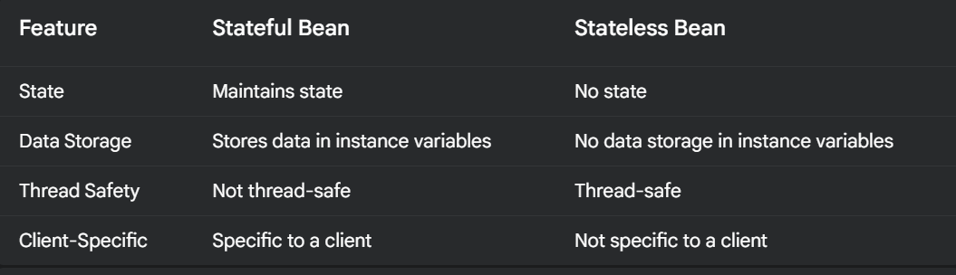

**Important Spring Annotation:**

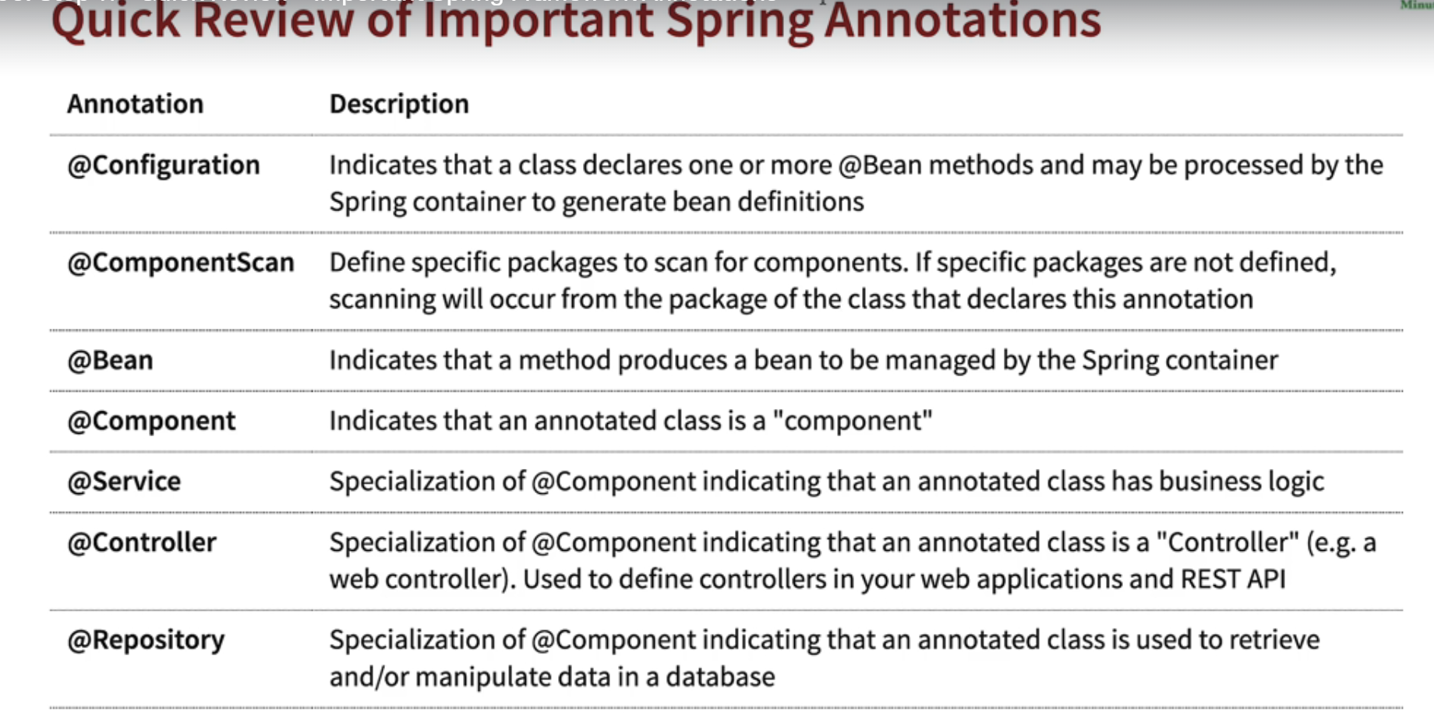

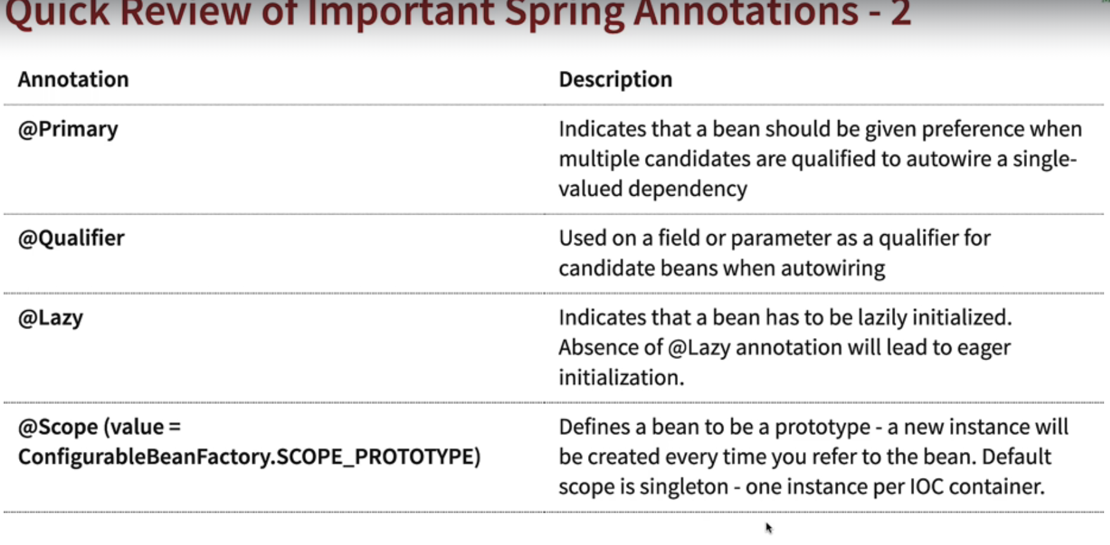

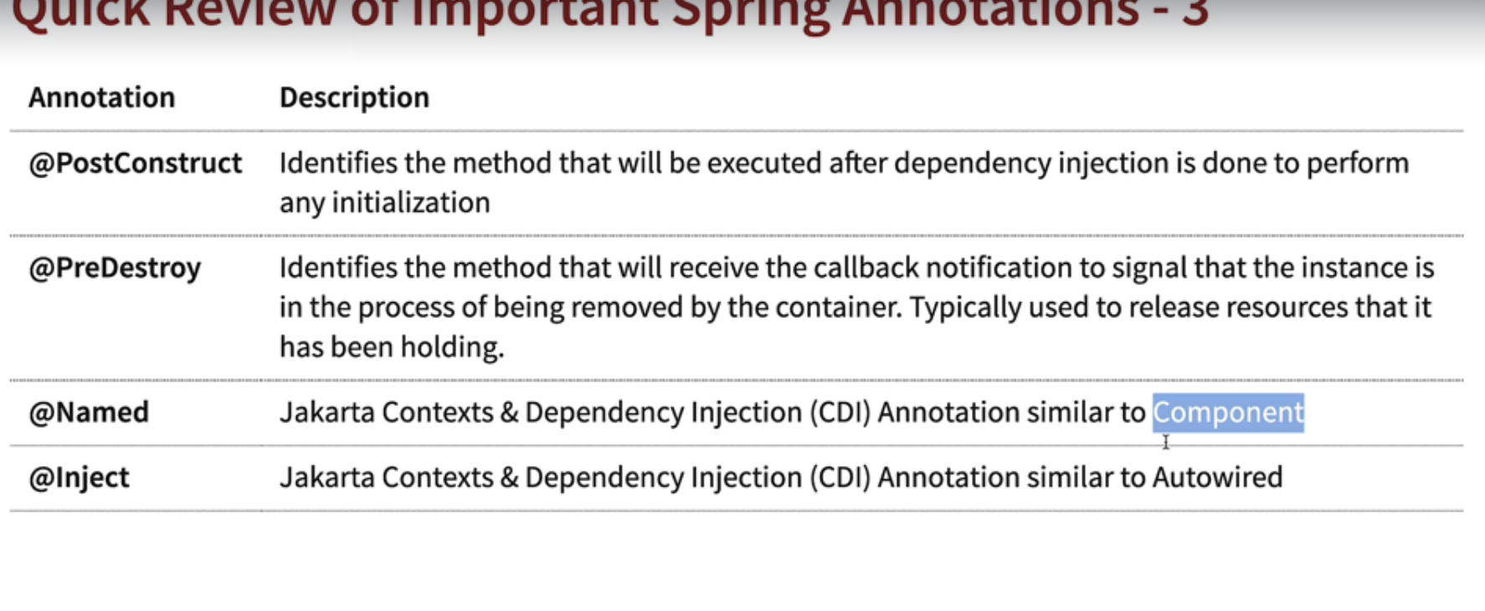

**Maven:**

Maven is a build tool that helps manage project dependencies (external libraries).

Spring version scheme- Major|Minor|Patch[/Release]

Spring Boot features:

Profiles:

Profiles enables developers to have environments specific configurations for the application code.

Spring boot actuator:

Actuator provides multiple endpoints to see applications metrics for the monitoring purposes.

**Core Spring Boot:**

@ResponseBody:

The @ResponseBody annotation in Spring MVC (and other Spring-based web frameworks) signals to Spring that the *return value* of a controller method should be written *directly* into the HTTP response body, rather than being interpreted as a view name. Think of it as bypassing the typical view resolution process.

**RequestBody**

You use @RequestBody as a parameter annotation in your Spring controller methods.

When a client sends a request with a body, Spring uses an HttpMessageConverter to transform the request body into the specified Java object.

@RequestBody instructs Spring to convert the HTTP request body (typically in JSON or XML format) into a Java object. This process is known as deserialization.

This allows you to easily access and process the data sent by the client within your controller methods.

**Swagger:**

**API Documentation:**

* Swagger provides a standardized format for documenting RESTful APIs. This allows developers and other stakeholders to easily understand how an API works.
* Tools like Swagger UI then take these specifications and generate interactive documentation, making it easy to explore and test API endpoints.

**API Design:**

* Swagger facilitates a "design-first" approach to API development. This means that you can define the API's structure and behavior before writing any code.
* Tools like Swagger Editor allow you to create and validate API specifications, ensuring consistency and accuracy.

**API Testing:**

* Swagger UI enables developers to directly test API endpoints within a user-friendly interface. This simplifies the process of verifying that an API is functioning as expected.

**Spring Boot Concepts (Hibernate):**

**JPA:**

**JPA** is a specification for accessing, managing, and persisting data between Java objects and a relational database. It defines a set of interfaces and standards for object-relational mapping (ORM).

**JDBC:  
JDBC as the Base:** Hibernate ultimately relies on JDBC to communicate with the database. It uses JDBC under the hood to execute SQL statements and fetch results.

**Hibernate:**

**Hibernate** is a popular open-source object-relational mapping (ORM) framework for the Java programming language. It simplifies the process of interacting with databases by mapping Java objects to relational database tables.

For DB Connection, connection properties will be defined in application properties files

**To check Command Liner in spring boot

**Key Differences**

|  |  |  |
| --- | --- | --- |
| **Feature** | **EntityManager** | **JpaRepository** |
| **Abstraction Level** | **Low-level** | **High-level** |
| **Functionality** | **Core JPA interface, provides direct access to database operations** | **Extends CrudRepository, simplifies CRUD operations** |
| **Querying** | **Requires writing custom queries or using the Criteria API** | **Supports query method implementation** |
| **Boilerplate** | **More boilerplate code required** | **Reduces boilerplate code** |

**EntityManager is the foundational interface for interacting with the database in JPA, while JpaRepository builds upon it to provide a more convenient and developer-friendly abstraction for common use cases. The choice between them depends on the specific requirements of your application and the level of control you need over database interactions.**

**@Repository:**

* **Exception Handling:** By default, @Repository enables Spring's exception translation mechanism. This means that unchecked exceptions thrown by the data access layer (like SQLException) are automatically converted into Spring's DataAccessException hierarchy. This simplifies exception handling and provides a more consistent way to deal with database-related issues.
* **Improved Readability:** The annotation improves the readability and maintainability of your code by clearly identifying the classes that interact with the data store.
* **Consistency:** Encourages a consistent approach to data access within your application. 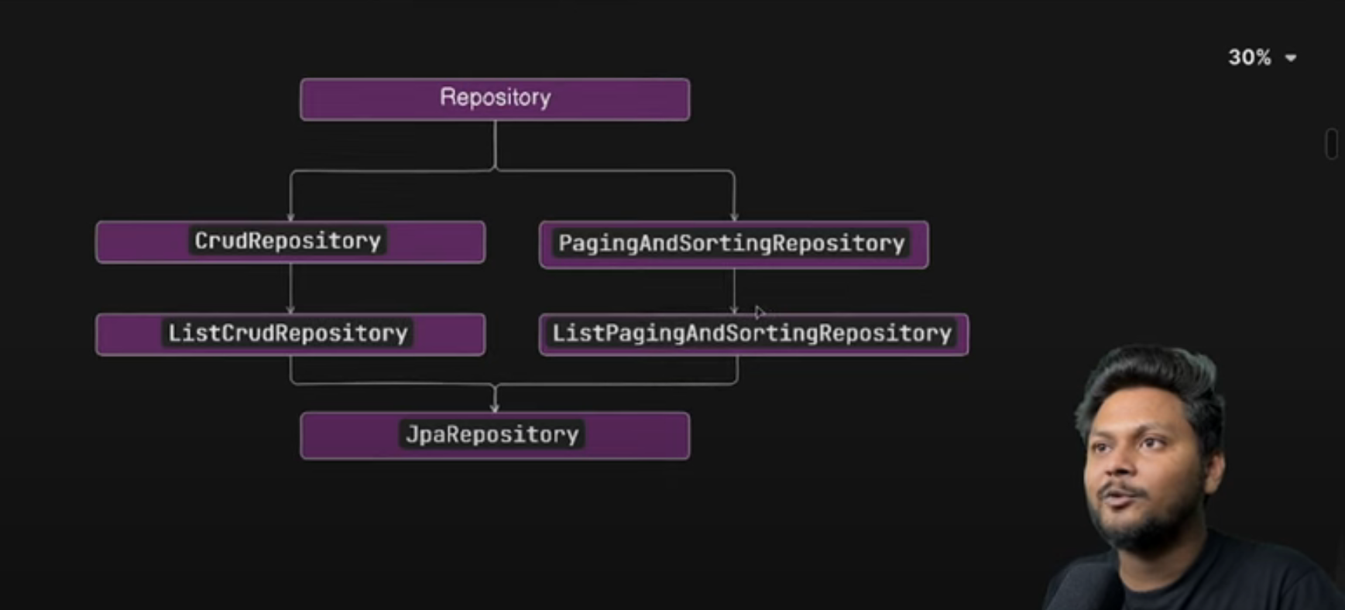
* 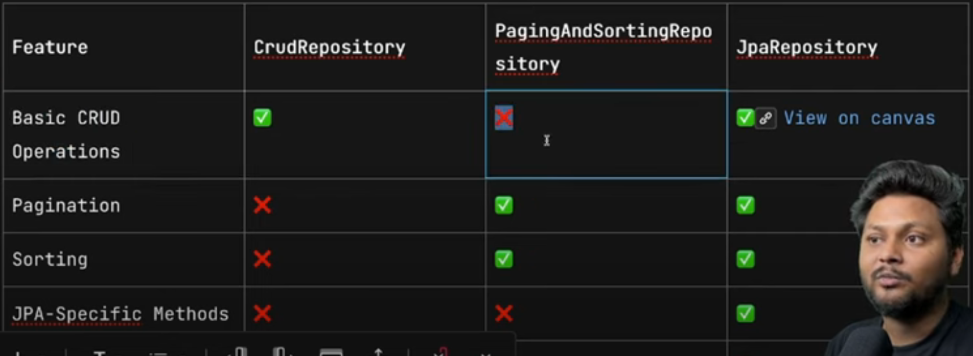
* 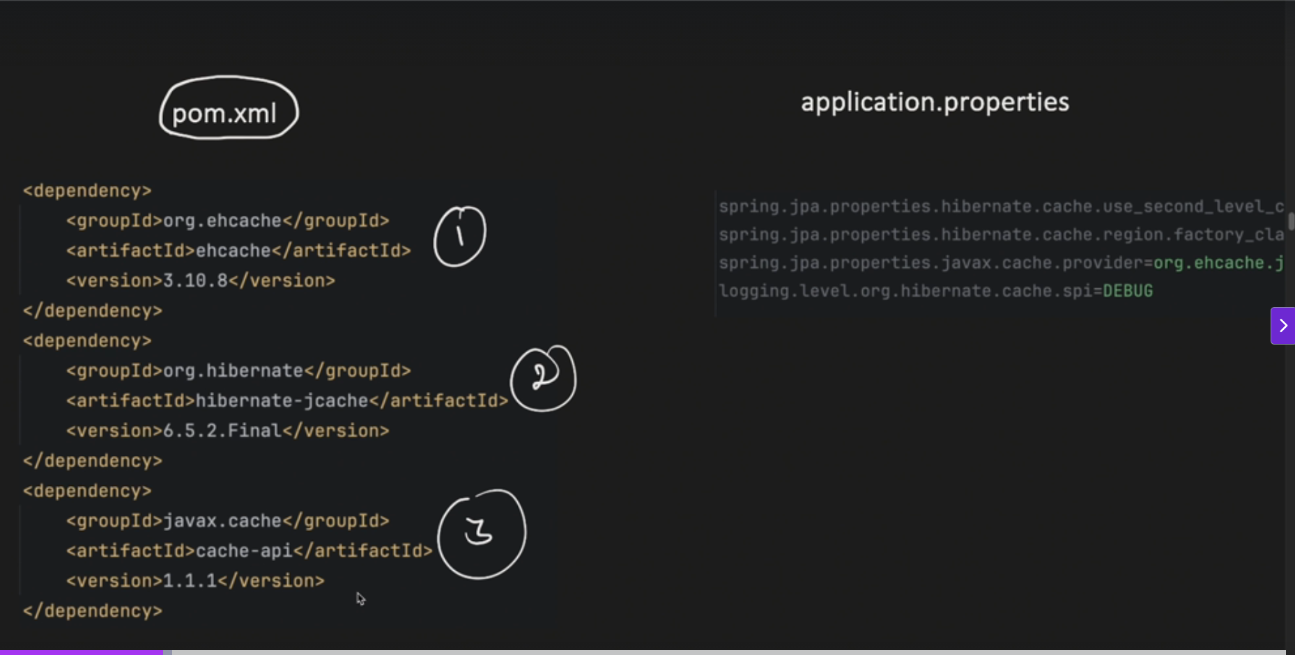
* 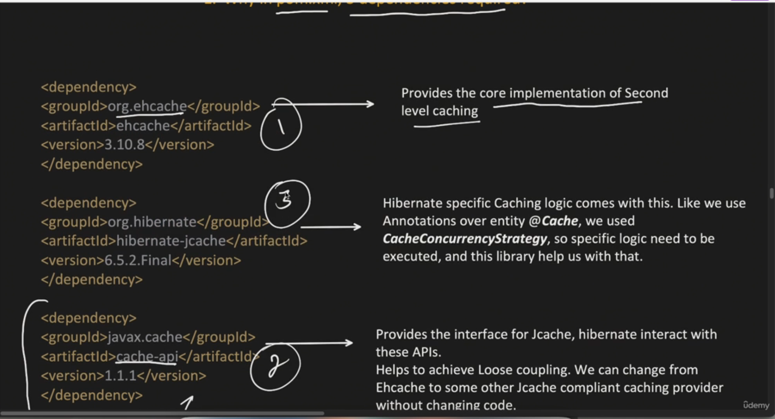

Spring MVC:

Model 🡪 Data to generate the view

View 🡪Show information to the user

Controller 🡪Controls the flow

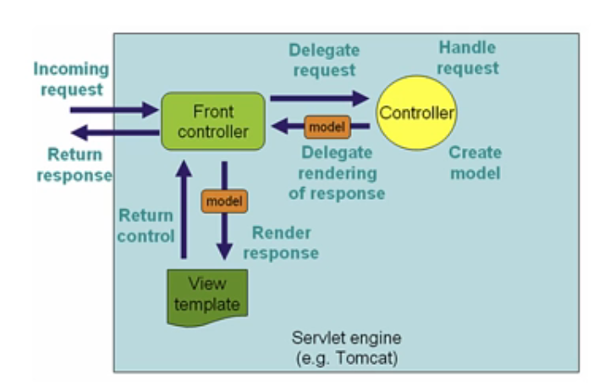

n Spring MVC, a ModelMap is essentially a container that holds data that you want to pass from your controller to your view. Here's a breakdown:

* **Purpose:**
  + It's used to transfer data from the controller to the view (like a JSP page or a Thymeleaf template).
  + This data can be any Java object, such as strings, lists, or custom objects.
* **Functionality:**
  + ModelMap is an extension of LinkedHashMap, so it behaves like a map, storing data in key-value pairs.
  + You add data to the ModelMap using methods like addAttribute(String attributeName, Object attributeValue).
  + In the view, you can then access this data using the attribute names.
* **Relationship to Model:**
  + Spring MVC also provides a Model interface, which serves a similar purpose.
  + In many modern Spring MVC applications, Model is generally preferred.
  + ModelMap is still available, and in many cases can be used interchangably with the Model interface.
  + Essentially, both Model and ModelMap are used to provide data to the view.

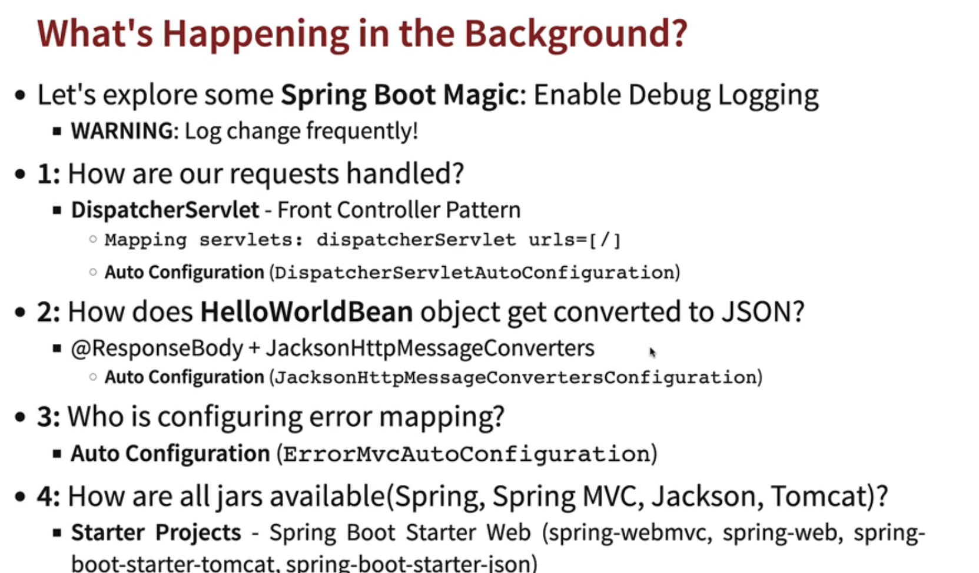

**Request Methods for REST API:**

**GET**-Retrieve the details of a resource

**POST**-Create a new resource

**PUT**-Update the resource

**PATCH**-Update a part of resource

**DELETE**-Delete a resource

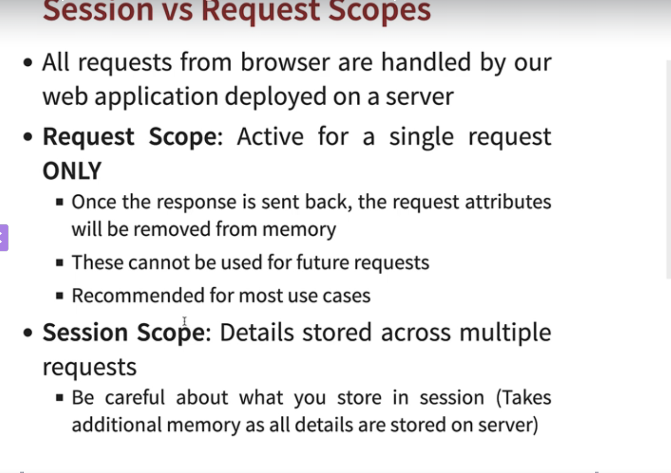

JSTL:

**jakarta.servlet.jsp.jstl-api**: This dependency provides the JSTL API.

**org.glassfish.web:jakarta.servlet.jsp.jstl**: This dependency provides the implementation of the JSTL. You should use the version that matches the API version. The runtime scope indicates that this dependency is needed at runtime but not during compilation.

**Caching:**

* Works in the concept of locality
* Can be done on both client and server instead of hitting the database for same data.
* Without cache mechanisms, systems will be slow

**Caching in Hibernate:**

**1. First-Level Cache (Session-Level Cache)**

* **Scope:** Bound to a single Hibernate Session object.
* **Behaviour:**
  + Automatically enabled by default.
  + Stores entities loaded or created within a specific Session.
  + When an entity is requested, Hibernate first checks the L1 cache. If found, the cached instance is returned.
  + Changes made to entities within a transaction are automatically reflected in the L1 cache.
* **Key Features:**
  + Transactional: Changes made within a transaction are cached and committed together.
  + Improves performance within a single transaction or request.

**2. Second-Level Cache (SessionFactory-Level Cache)**

* **Scope:** Shared across multiple Session objects within the same SessionFactory.
* **Behavior:**
  + Requires explicit configuration to enable.
  + Stores entities across multiple transactions.
  + If an entity is not found in the L1 cache, Hibernate checks the L2 cache.
  + Often uses external cache providers like Ehcache or Redis for efficient storage and management.

**Hibernate States:**

Transient State

Persistent State

Detached State

Removed State

**State Transitions:**

* **Transient -> Persistent:**
  + Occurs when an object is saved or persisted using methods like session.save() or session.persist().
* **Persistent -> Detached:**
  + Occurs when the session is closed or the object is evicted from the session's cache.
* **Detached -> Persistent:**
  + Occurs when a detached object is re-attached to a session using methods like session.update(), session.merge(), or session.saveOrUpdate().
* **Persistent -> Removed:**
  + Occurs when the delete () method is called on the object.

REST API:

**REST API (Representational State Transfer Application Programming Interface)**

A REST API is a software architecture style that defines a set of constraints for designing and developing web services. It's a popular approach for building APIs because of its simplicity, flexibility, and scalability.

**Key Principles of REST:**

* **Client-Server Architecture:** Separates the client (consumer) from the server (provider) for loose coupling.
* **Statelessness:** Each request from the client must contain all the necessary information for the server to understand and process it. The server doesn't store any session information between requests.
* **Cacheability:** Responses can be cached to improve performance and reduce load on the server.
* **Layered System:** The architecture can have multiple layers (e.g., load balancers, proxies) between the client and server without affecting their interaction.
* **Uniform Interface:** Uses a consistent set of operations (e.g., GET, POST, PUT, DELETE) and data formats (e.g., JSON, XML) for interacting with resources.

**How REST APIs Work:**

1. **Client:** Sends a request to the server using HTTP methods (GET, POST, PUT, DELETE) to interact with a specific resource (e.g., a user, a product, a blog post).
2. **Server:** Receives the request, processes it, and sends a response back to the client. The response typically includes the requested data in a specific format (e.g., JSON).

**HTTP request structure:**

**1. Request Line**

* **Method: The HTTP method specifying the desired action (e.g., GET, POST, PUT, DELETE).**
* **Request-URI: The Uniform Resource Identifier (URI) of the resource being requested.**

**Example:**

* GET /api/users HTTP/1.1

**2. Header Fields**

* **General Headers:** Provide general information about the request (e.g., Cache-Control, Date).
* **Request Headers:** Provide information specific to the request (e.g., Host, User-Agent, Accept).

**3. Message Body (Optional)**

* The data associated with the request, typically present in POST, PUT, and DELETE requests.
* The format of the message body is specified by the Content-Type header.

**HTTPS Response structure:**

**1. Status Line**

* **HTTP-Version:** The version of the HTTP protocol used (e.g., HTTP/1.1).
* **Status-Code:** A 3-digit numeric code indicating the status of the request (e.g., 200 OK, 404 Not Found, 500 Internal Server Error).

**2. Header Fields**

* **General Headers:** Provide general information about the response (e.g., Date, Server).
* **Response Headers:** Provide information specific to the response (e.g., Content-Type, Content-Length, Location).

**3) Message Body (Optional)**

* The data returned by the server in response to the request.
* The format of the message body is specified by the Content-Type header.

**HATEOAS in Spring Boot:**

HATEOAS is the concept within REST that enables the client to interact with the RESTful service entirely through hyperlinks provided dynamically by the service itself. It means the client does not need to hardcode the URIs of the resource but can discover them at runtime.

In Spring Boot, HATEOAS can be implemented using the spring-boot-starter-hateoas dependency which allows the easy creation of hypermedia links and resources. With HATEOAS each resource representation returned by the server can contain the links to related resources or actions that the client can follow.

Serialization:

In Spring Boot, serialization refers to the process of converting Java objects into a format that can be easily stored or transmitted, such as JSON or XML. Conversely, deserialization is the process of converting that stored or transmitted format back into Java objects. Here's a breakdown of how it applies within the Spring Boot context:

**Common Use Cases:**

* **RESTful APIs:**
  + Spring Boot's REST controllers commonly use serialization to convert Java objects into JSON responses, which are then sent to clients.
  + Similarly, deserialization is used to convert incoming JSON requests into Java objects.

**Key Technologies:**

* **Jackson:**
  + Jackson is the default JSON processing library in Spring Boot. It provides powerful and flexible serialization/deserialization capabilities.
* **JSON:**
  + JSON (JavaScript Object Notation) is a widely used data format for exchanging data between applications.

  Spring AOP:

**Spring and AOP:**

* Spring AOP is a key feature that helps address cross-cutting concerns.
* Cross-cutting concerns are aspects of a program that "cut across" multiple modules or layers. This means they're not confined to a single, specific part of the application.
* They are functionalities that are needed throughout the application.

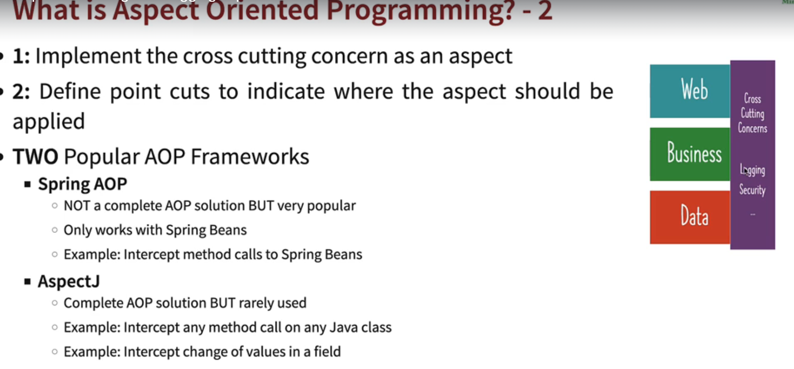

* Advice: This is the "what" – the actual code that performs the cross-cutting concern (e.g., logging, security check, transaction management).
* Pointcut: This is the "where" – the expression that determines the specific join points (e.g., method executions) where the advice should be applied.

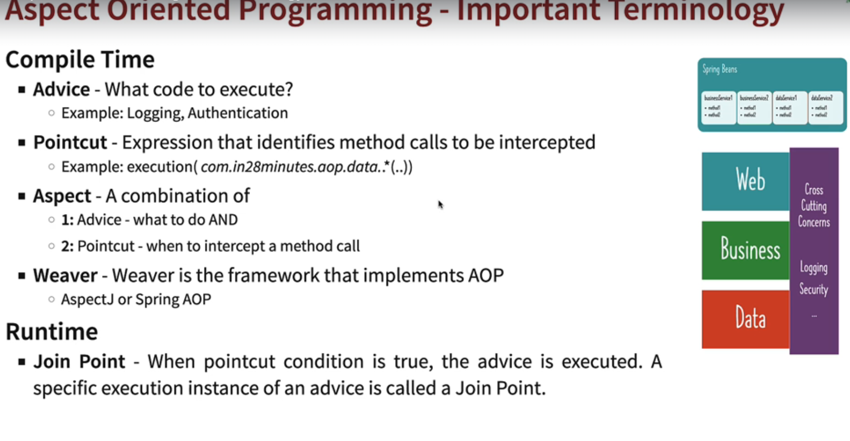

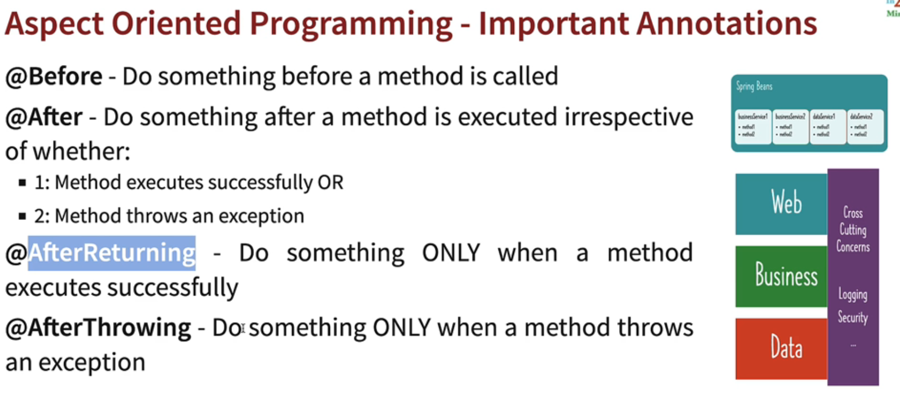

Key Differences from @After:

* Execution Condition:
  + @After: Executes regardless of whether the join point completed successfully or threw an exception.
  + @AfterReturning: Executes *only* if the join point completed successfully.
* Accessing Returned Value:
  + @AfterReturning provides direct access to the returned value of the join point.
  + @After does not directly provide access to the returned value.

Microservices:

Advantages of microservices over monolith and service-oriented architecture:

Parallel development

Agility

Scalability

Useability

Cons:

Complex infrastructure and architecture

Security, cross cutting concerns.

**Definition of microservices:**

The microservice architectural style is an approach to developing a single application as a suite of small services, each running in its own process and communicating with lightweight mechanisms, often an HTTP resource API. These services are built around business capabilities and independently deployable by fully automated deployment machinery.

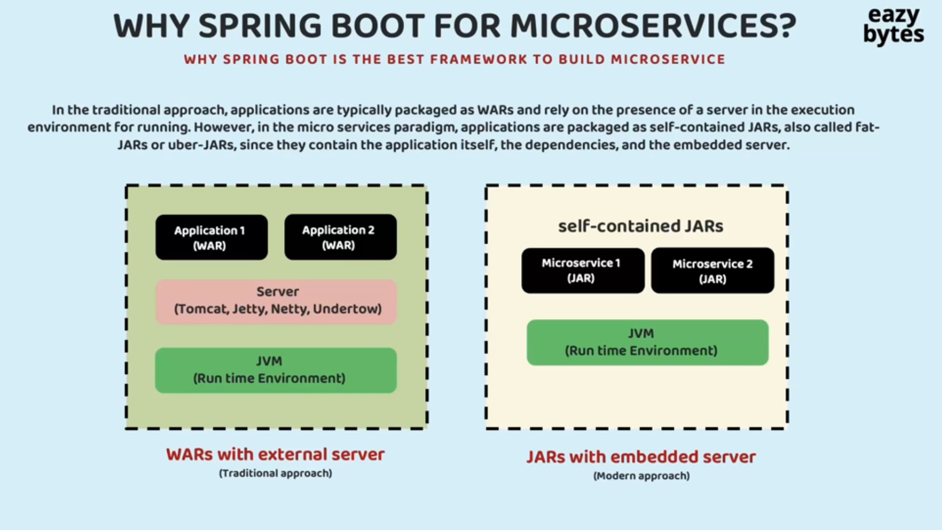

JAR 🡪 is bundle of .class files

WAR 🡪 is a bundle of web files (It represents a web application)

EAR 🡪 One or more JARs and WARs, META-INF folder.

Communication between Two services:

Synchronous

Asynchronous

Synchronous ways:

* Rest Template
* Rest Client
* Feign Client

In the context of a **REST API call**, **Keep-Alive** refers to a mechanism that allows a single **TCP connection** to remain open for multiple HTTP requests/responses, rather than opening a new connection for each request. This is part of the **HTTP persistent connection** feature.

To make an API call using **plain Java** (without Spring or other frameworks), you can use the built-in HttpURLConnection class or the newer HttpClient introduced in Java 11.

Flow of a HTTP Request:

HttpURLConnection forms the request(sets the header and body) 🡪Checks the TCP connections in KeepAlive cache🡪 If not present in cache creates a new TCP connection 🡪 Makes Request 🡪 Receives Resposne

In HTTPS 1.1 🡪 Keep alive is set to true, So until the timeout the TCP connection remains persistent.

When Keep alive is set to true, a cache is maintained to make the TCP connection is stored

Disadvantage of plain Java Connection:

* Too Much of boiler plate code in-order to initiate a connection.
* Difficulty in mapping the response to corresponding Object.

**RestTemplate**.exchange 🡪 Used when we want to have control over the Http header , request body and spring takes care of automatic response conversion.

RestClient:

Diff Between RestTemplate and RestClient:

|  |  |  |
| --- | --- | --- |
| **Feature** | **RestTemplate (Spring)** | **RestClient (Java 21+)** |
| **Requires Spring** | ✅ Yes | ❌ No |
| **Native to Java** | ❌ No | ✅ Yes |
| **Async Support** | ❌ Limited | ✅ Full support |
| **Recommended for New Projects** | ❌ Deprecated-ish | ✅ Modern and preferred |
| **Serialization Support** | ✅ Built-in with Jackson | ❌ Manual or external libs |

**RestTemplate**

**RestTemplate** is a synchronous, blocking client that has been the standard way to make REST calls in Spring for many years. It uses a template-based API, providing a large number of overloaded methods for different HTTP operations (e.g., getForObject, postForEntity). While it is highly configurable and easy to use for simple, synchronous requests, its blocking nature can lead to performance issues in applications that require high concurrency. It is now considered deprecated in Spring.

**RestClient(Fluent Based API🡪 chaining of method call)**

**RestClient** is a newer synchronous client introduced in Spring 6 and Spring Boot 3 as a modern replacement for RestTemplate. It is built on top of the non-blocking WebClient but provides a synchronous, blocking API. Its key features include a fluent and concise API, which makes the code more readable and easier to maintain. Because it's built on WebClient, it shares the same underlying infrastructure for things like message converters and request factories, making it more future-proof and the recommended choice for new projects.

FeignCLient:

FeignClient is a declarative web service client provided by **Spring Cloud**. It simplifies the process of making HTTP requests to external services in a microservices architecture. Instead of writing boilerplate code using RestTemplate or WebClient, you can define an interface and annotate it with @FeignClient, and Spring will automatically generate the implementation at runtime.

Service Discovery:

In Microservices , the service instance are created and deleted dynamically.we cannot hardcode the url of a particular service as it’s not scalable

Spring Cloud:

Spring Cloud provides set of tools and libraries , which helps to build distributed microservices.

* Service Discovery
* Client-side load Balancing
* Circuit Breaker and Resilience
* API Gateway
* Distributed Tracing
* Centralized Configuration

Open Feign follows declarative approach for communicating with Microservices

Oauth:

**OAuth 2.0 is primarily an *authorization* framework**, not an authentication protocol.

**Authentication**:

It does **not verify the identity** of the user. It only confirms that the user has granted access to a resource.

https://notebook.zohopublic.in/public/notes/bietv949cfd82a5804e0ea1d18400d3ff6fa3

Spring Security Flow:

